# Library Management System v1.0 Quick Start Guide

## The Home Screen

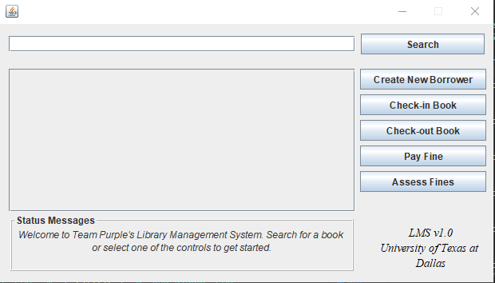

Figure 1. LMS Home Screen

The home screen is the main entry point for the Library Management System. It contains all of the controls for a user of the system.

## The Search Box

The search box will allow you to query for a book within the library. You may search for an ISBN10, author name, or book title to find corresponding matches. Once you some desired search parameter, you may execute the search by clicking the “Search” button to the right of the search box.

Upon a successful search, you may scroll vertically and horizontally to view the Isbn10, Title, Author(s), and whether or not the book is available for Check-out. If searches come back empty, you will be notified; you will also be notified of the number of books a particular search returns.

## Check-out Book

Books may be checked out given a valid Isbn10 value and a valid borrower Card ID. In order to check-out a book, a user and the desired book must meet the following requirements:

* The Isbn and Borrower Card ID must be valid
* You must have less than 3 books currently checked out as a borrower is only permitted to check-out a maximum of three books at a time
* The user must not have any unpaid fines
* The book must not already be checked-out

## Check-in Book

A user may search for Checked-out books given a books ISBN10 number, the borrowers name, or the borrowers Card ID. The user will then see a list of relevant books on loan and may opt to Check-in these books.

*As the requirements were given, this does not prevent a user from checking-in another user’s book. This is the fault of the given design and is allowed within LMS to conform to the given design principles.*

## Status Messages

The Status Messages is a text pane that appears to give the user helpful information as they use the LMS. For example, if a user were to try to search but no books appear, a status message telling the user that no books were returned is displayed; they may also be told to try to be less specific in their search criterion.

There are a variety of messages for different cases, so look to the Status Messages when you have questions while using the LMS.

## Create New Borrower

New borrowers may be created within the LMS as well. In order to create a new borrower, the following information is required

* Borrower Name
* Borrower Address
* Borrower Social Security Number
* Phone Number (OPTIONAL)

Once the given information has been provided, a new borrower within the LMS will be created.

## Pay Fines

A user will be shown the list of all of their outstanding fines given their Card ID. They may make fine payments on each of these loans given that the book has been returned. Otherwise, the fine amount will continue to accrue.

If the user wishes to view the sum of all fines for each user with unpaid fines, then the Card ID field in Pay Fines should be left blank.

## Assessing Fines

Fines can be assessed using the “Assess Fines” button. This will see if any book loans have become outstanding (where the due date has passed). Applied fines will be 25 cents for each day past the due date (returned or otherwise).